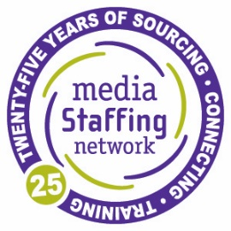
MEDIA SALES MANAGER—SMALL MARKET, WESTERN US
Position Summary
A well-respected, national radio group is looking for an outstanding Senior Sales Manager for a large radio cluster located in a small Western market. All level sales managers will be considered. This opportunity is tailor-made for a highly versatile and experienced sales manager for a multi-platform radio, events, and digital operation. This manager must have a proven track record of performance in maximizing revenue, inventory, and employee performance and be a leader in the community. Opportunities for upward career movement exist with this position.
This is a world-class area for all types of outdoor living experiences, is in close proximity to National Parks, and is in one of the most beautiful, scenic parts of the country.
Position Requirements

- Media experience managing multiple stations and managing multiple sellers is preferred
- Particular experience in identifying, qualifying, and landing new local direct accounts, and an understanding that this is where the greatest opportunity lies for local radio
- An understanding of digital media trends and the ability to package digital assets
- Experience in the maximization of all sales assets
- Ability to direct sales forecasting activities, set goals and develop strategic plans to achieve local market and company goals
- Outstanding leadership skills and the passion for developing and growing talent, especially in helping them focus on building more, new local direct business
- Strategic thinking and vision to create projects and develop big ideas
- Data analysis skills and ability to evaluate activities of market competition
- Experience with small-market hallmarks such as high-school sports and community outreach
- Agriculture advertising experience is a plus
- Must be detail-oriented with excellent grammar, written, and verbal communication skills
- Proficient with Excel, Nielsen, and CRM-related software; RAB Account Manager CRM experience a plus
- College degree preferred

Position Responsibilities (including but not limited to)

- Maximize all market assets including over the air, streaming, and digital assets
- Consistently achieve all revenue goals, control rate, and inventory management
- Handle a select number of house accounts
- Explore ways to extend the advertiser’s/sponsor’s reach in relevant ways within the brands’ capabilities
- Bridge the community of local businesses to the community of connected consumers through networking and community leadership
- Lead training, coaching, and implementation of the new economics of the radio business
- Oversee and supervise all aspects of the sales department while coordinating with other departments

All interested parties should submit their resumes to Kate Glenn, kate@mediastaffingnetwork.com

EOE

# # #

